

Practices for Secure Software Report

Table of Contents
Document Revision History 3
Client 3
Instructions 3
Developer 4
1. Algorithm Cipher 4
2. Certificate Generation 4
3. Deploy Cipher 4
4. Secure Communications 4
5. Secondary Testing 4
6. Functional Testing 4
7. Summary 4
8. Industry Standard Best Practices 4

Document Revision History

Version | Date | Author | Comments
1.0 | June 18, 2026 | Alex Wyatt | Initial Release

Client



Instructions

Submit this completed practices for secure software report. Replace the bracketed text with the relevant information. You must document your process for writing secure communications and refactoring code that complies with software security testing protocols.

- Respond to the steps outlined below and include your findings.
- Respond using your own words. You may also choose to include images or supporting materials. If you include them, make certain to insert them in all the relevant locations in the document.
- Refer to the Project Two Guidelines and Rubric for more detailed instructions about each section of the template.

Developer
Alex Wyatt

Algorithm Cipher

To secure Artemis Financial’s application, two cryptographic standards are required: SHA-256 for data transmission integrity and AES-256 for resting data confidentiality.

For the file verification step requested by the client, I implemented the SHA-256 one-way hash function. SHA-256 generates a fixed-length 256-bit checksum of the transmitted data. If a single byte is altered during transmission, the hash completely changes. Because 256-bit outputs create an astronomical number of possible combinations, collision attacks are computationally impossible on modern hardware.

For general data encryption, the Advanced Encryption Standard with a 256-bit key length is the recommended cipher. Historically, systems relied on the Data Encryption Standard using a 56-bit key. As hardware scaled, DES became easily broken via brute-force attacks. The National Institute of Standards and Technology adopted AES to future-proof against modern computing power. AES is a symmetric cipher, meaning the exact same key is used to lock and unlock the data. To ensure this symmetry remains secure, the system must utilize Java’s SecureRandom class, which pulls true entropy directly from the host operating system's hardware to generate unpredictable keys and Initialization Vectors.

Certificate Generation
Insert a screenshot below of the CER file.

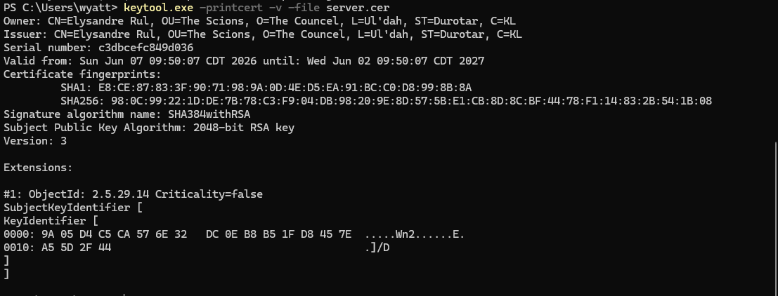

Deploy Cipher
Insert a screenshot below of the checksum verification.

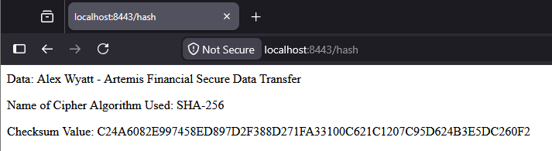

Secure Communications
Insert a screenshot below of the web browser that shows a secure webpage.

Secondary Testing
Insert screenshots below of the refactored code executed without errors and the dependency-check report.

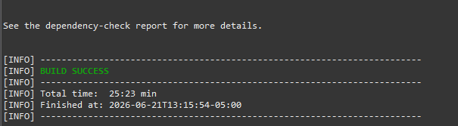

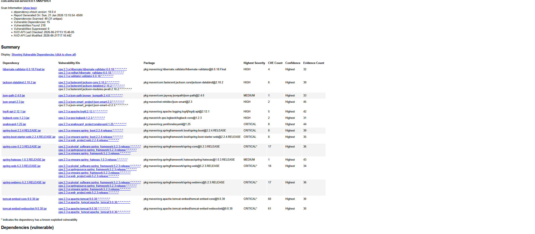

Functional Testing
Insert a screenshot below of the refactored code executed without errors.

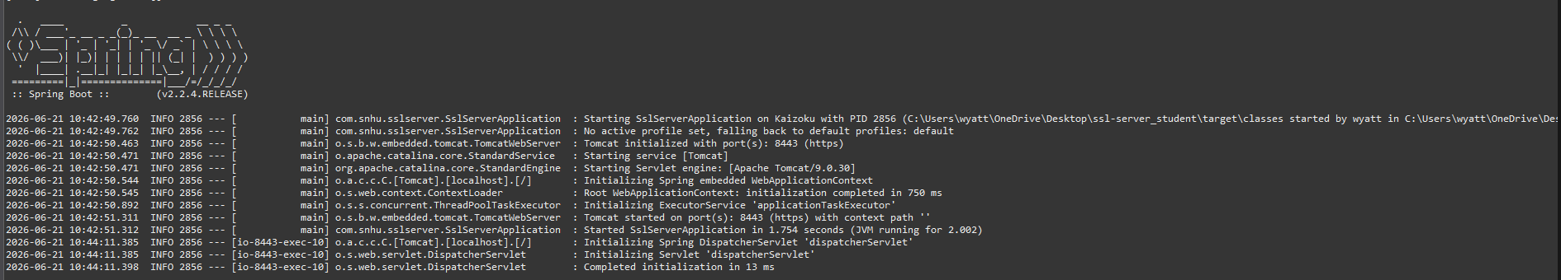

Summary

Based on the Vulnerability Assessment Process Flow, this refactoring successfully addressed three specific architectural nodes. First, Cryptography was mitigated via the implementation of the java.security.MessageDigest library, utilizing the SHA-256 cipher to guarantee data payload integrity through checksum verification. Second, Client/Server was secured by enforcing the HTTPS protocol across port 8443 and generating a self-signed JKS certificate to prevent unencrypted data transit and Man-in-the-Middle attacks. Finally, Code Quality was reinforced by integrating the OWASP dependency-check Maven plugin to automate static software composition analysis during the build phase.

The process for adding these security layers relies on a "shift-left" engineering mentality. Security was not treated as a final testing phase but was built directly into the transport layer, application layer, and supply chain. By replacing HTTP with HTTPS, applying one-way mathematical hashing to the data string, and forcing the compiler to check for known Common Vulnerabilities and Exposures before allowing the code to execute, the application is fundamentally hardened against external interception and compromised dependencies.

Industry Standard Best Practices

Industry standards established by the National Institute of Standards and Technology and the OWASP mandate that security must be an automated, objective baseline rather than a manual afterthought. To maintain the software application’s existing security while deploying new features, industry best practices such as automated DevSecOps pipeline gates were utilized. By explicitly mapping the pom.xml to the NVD 2.0 vulnerability database, the build environment automatically filters out compromised open-source libraries. Additionally, cryptographic standards were modernized by abandoning deprecated algorithms in favor of AES-256 for encryption and SHA-256 for data verification.

Applying these best practices is vital to Artemis Financial's overall corporate well-being. Because the company handles highly sensitive, individualized financial plans, it is subject to strict federal regulatory compliance frameworks. Building automated security scans into the CI/CD pipeline and enforcing TLS encryption across all web traffic prevents regulatory fines, eliminates the severe technical debt associated with patching breaches in a production environment, and guarantees the cryptographic confidentiality of client assets.

